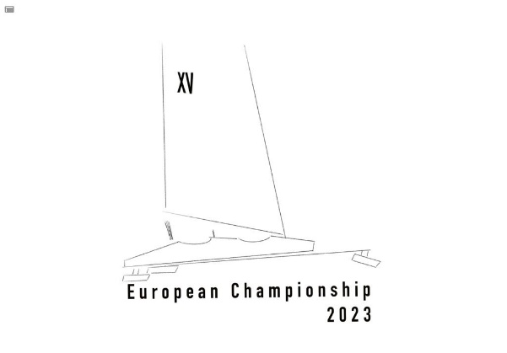
Entry Form
European Championship 2023
European Cup & Code-Zero Cup

Sail number:
Name of ice yacht:
Fuselage colour:

Helmsman
First and last name:
Address:
Country:
Cell phone:
E-mail:
Clothing size: S / M / L / XL / XXL / XXXL Man or S / M / L / XL Women

Crew
First and last name:
Address:
Country:
Cell phone:
E-mail:
Clothing size: S / M / L / XL / XXL / XXXL Man or S / M / L / XL Women
Additional People no.:
The social program (lunch snack and after sail drinks) are included for participants. For friends and/or family there will be a contribution ask on the base of cost price.
Additional order Hoody (€ 30,-pp.):
(please include size)
E-mail to: ec2023@monotype-xv.org together with a good and readable copy of the insurance policy with a 3rd party liability of minimum €500,000
When registered before January 10, 2023 , the helmsman and crew will receive a hoody (sweater) with Monotype logo!

